IBM Watson Health

Instructions to request access

Table of Contents

**Manager instructions for requesting access to server trvlapp3131(Sandbox)**

**Instructions to connect to server trvlapp3131 (Sandbox Server)**

**Instructions for requesting installation of packages on servers**

INSTRUCTIONS FOR MANAGER to REQUEST ACCESS TO TRVLAPP3131 (Sandbox server)

Below are the links for you to request the users accounts (individual/ team) for the new server- trvlapp3131 (sandbox server)

**Individual accounts:**  
The manager of each individual/ team will now need to submit an access request using the link below.  
<https://truvenhealth.service-now.com/th/catalog.do?uri=com.glideapp.servicecatalog_cat_item_view.do%3Fsysparm_id%3D83913e2e0d89da0056b405b603f6a141>

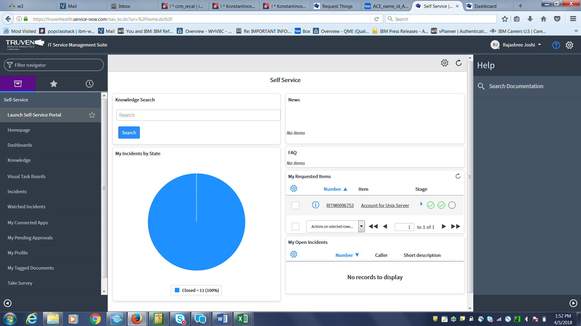

From this screen go to launch Self Service Portal

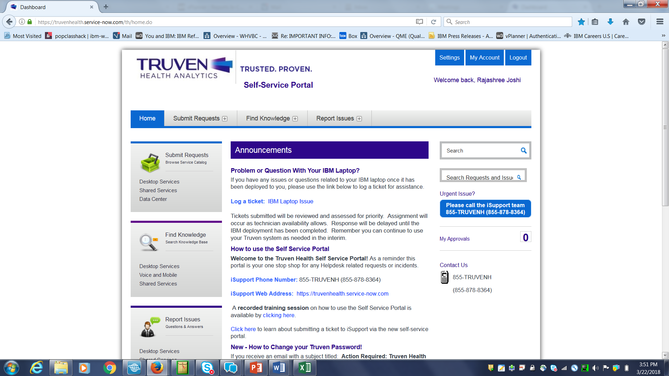

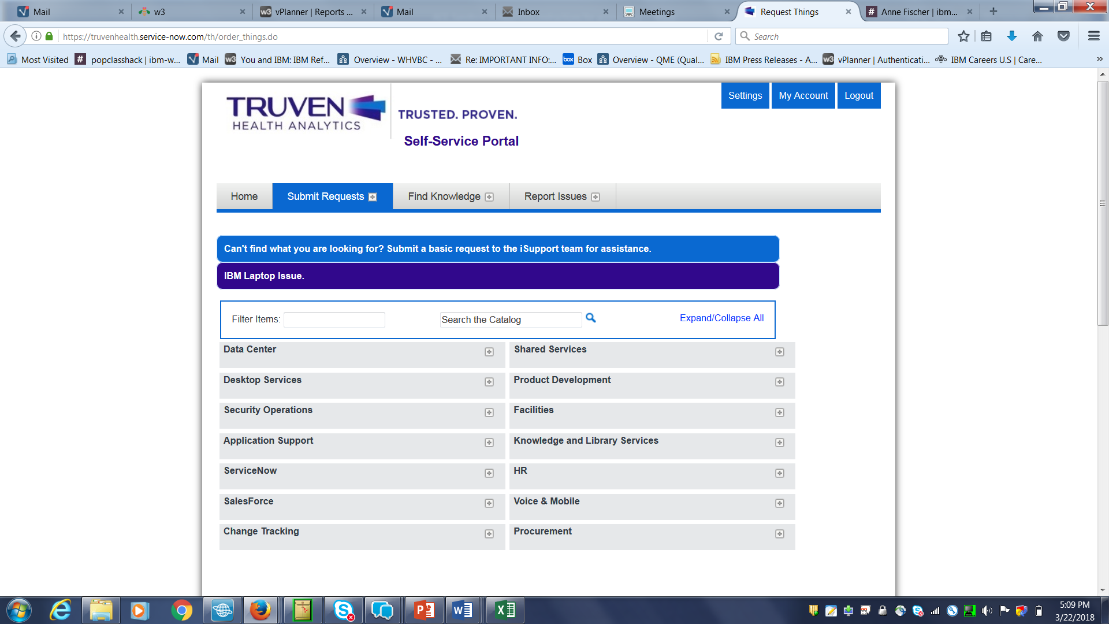

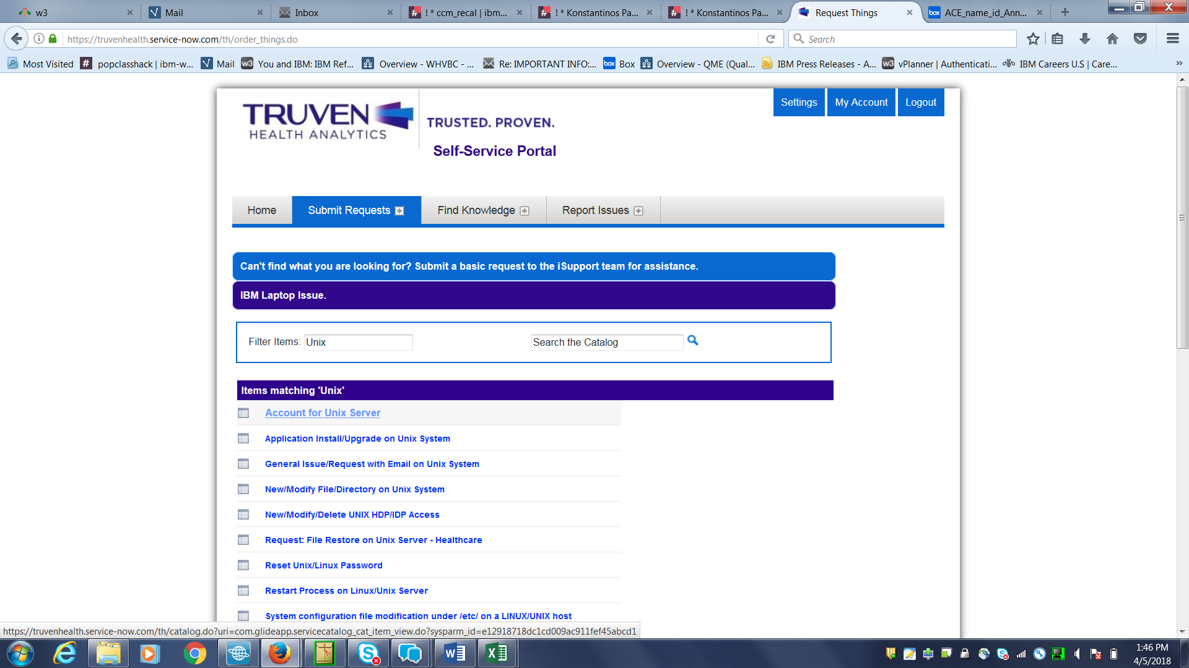

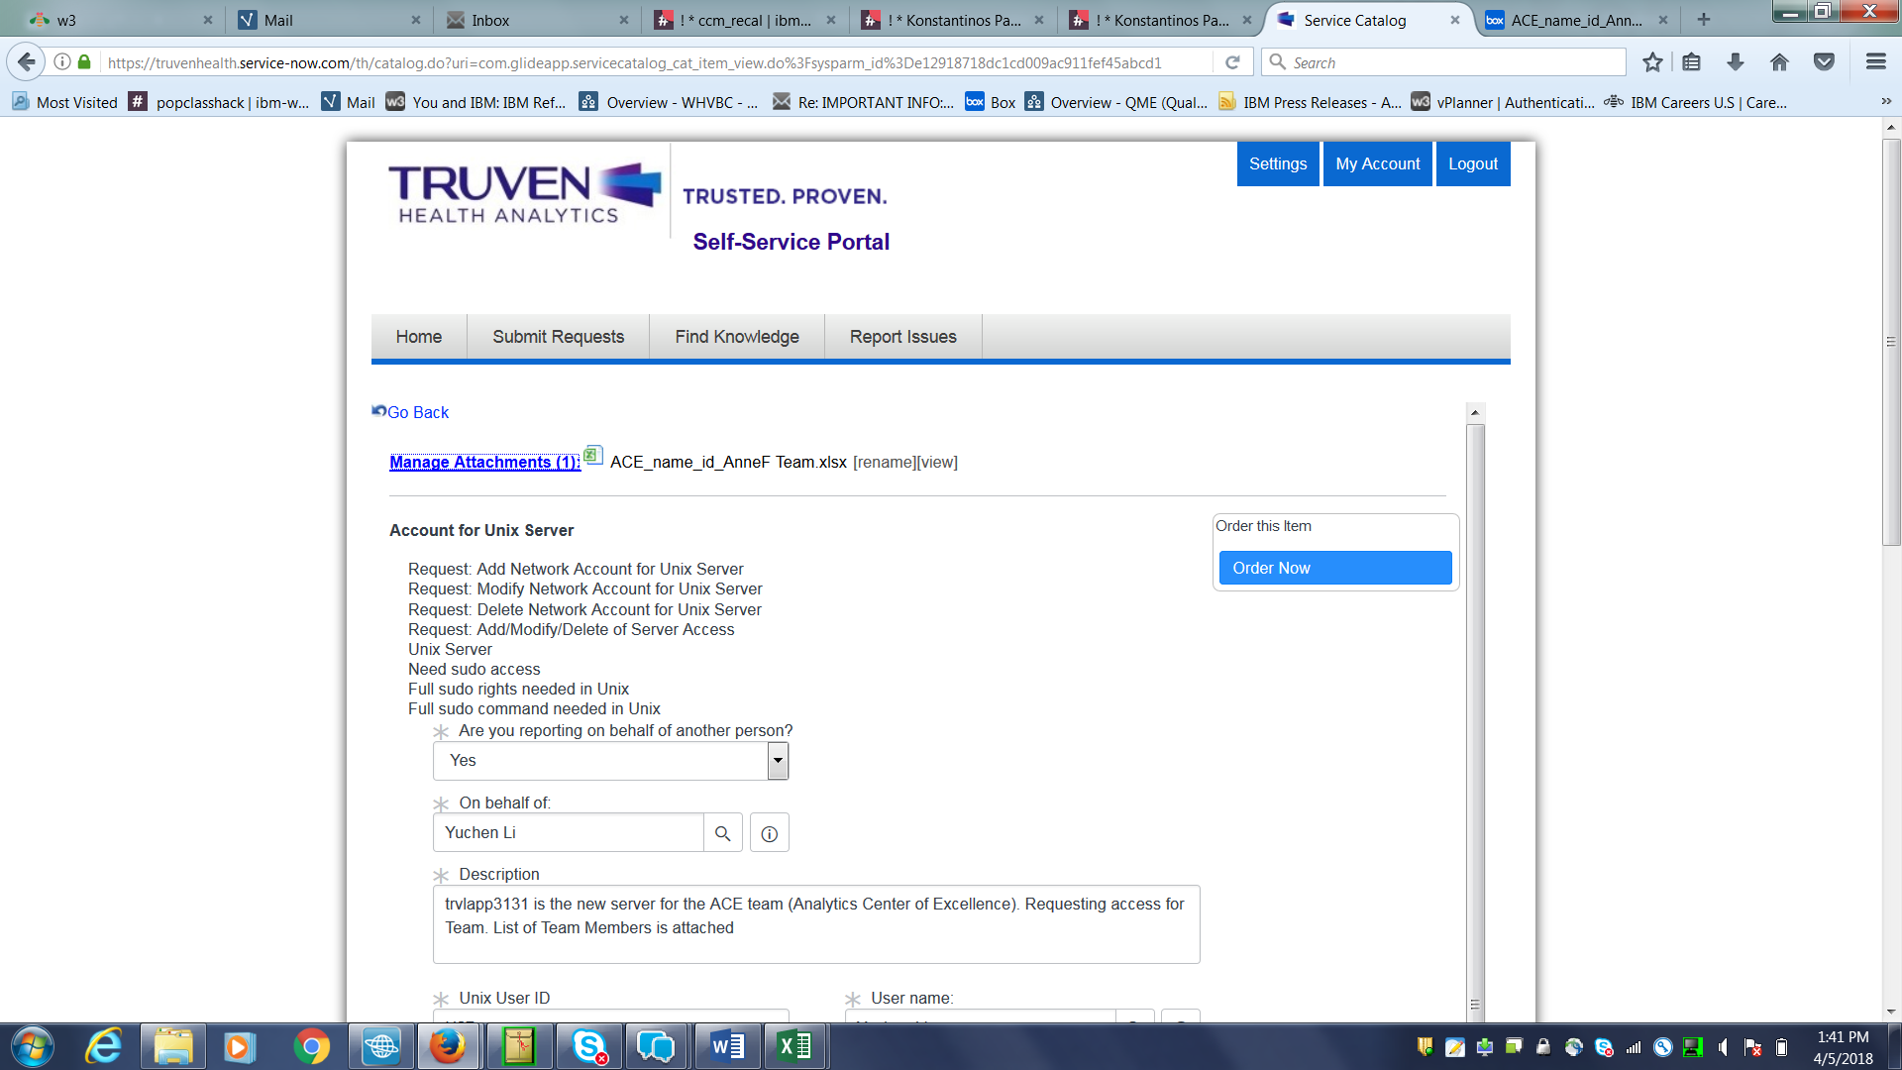

Under Manage Attachments, please go ahead and attach list of your team members with their Truven id’s and email addresses if you are requesting for more than 1 person at one time (see above)

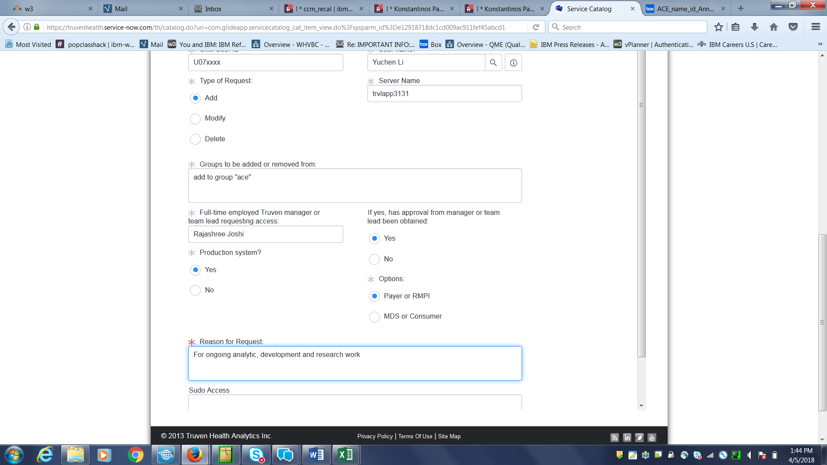

Once you are done filling on all the required fields, go to the right hand corner and hit the button “order now”. Your request will be submitted and you will receive confirmation

If you need to request to be added to a specific group- get the group name and follow instructions as mentioned above

INSTRUCTIONS to CONNECT TO SERVER TRVLAPP3131 (Sandbox Server)

How to connect to new server:

Option 1: Standard Putty SSH, command line only interface

Option 2: Custom Putty SSH Tunnel for Remote Desktop Gnome interface

Need to fill in Hostname, Source Port, Destination, Click Add, Click Open.

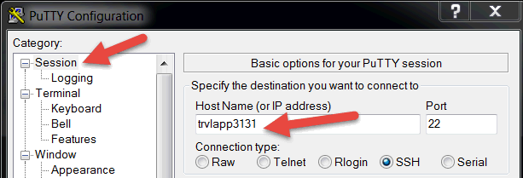

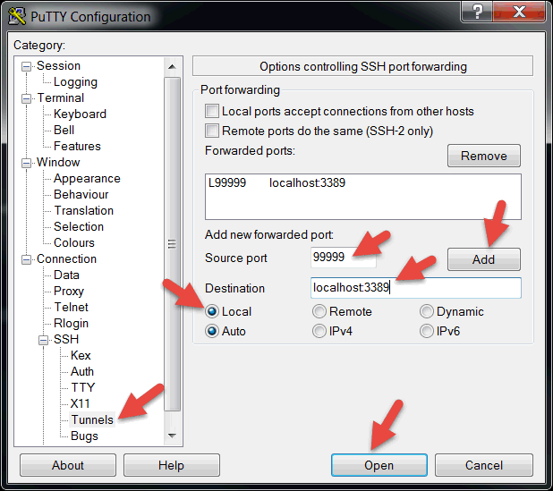

Login with IADWS credentials

From your workstation, Start->Run-> mstsc.exe

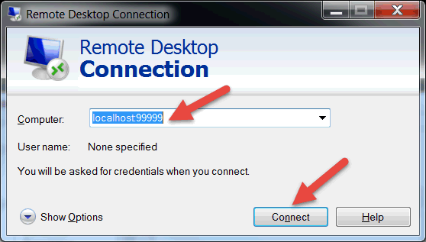

Login with IADWS credentials

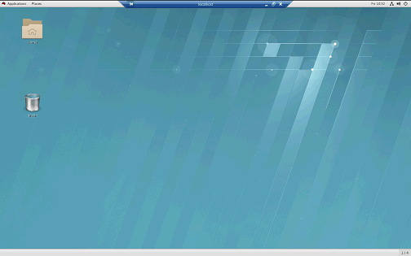

Top left menu pane, Choose Application -> System Tools -> Terminal

To Launch Jupyter Notebook:

/applications/anaconda2-4.4.0/bin/jupyter notebook

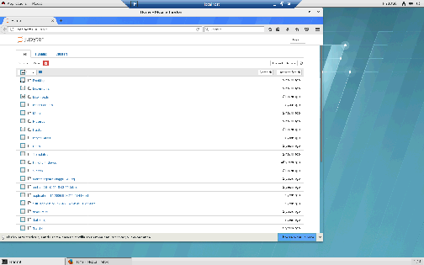

**INSTRUCTIONS FOR REQUESTING INSTALLATION OF PACKAGES ON SERVERS**

Please assess the packages individually to confirm if they are truly needed. Per CET Management, we request that a member of your team do the following for any additional software packages required:

1. Identify software/package version info

2. Check if package is IBM approved

3. Obtain IBM approval if needed

4. Submit a ticket using the link below for CET to install IBM approved packages  
[https://apps.na.collabserv.com/wikis/home?lang=en-us#!/wiki/W1f1fdb4b2ab6_4646_b124_3195f2816bb9/page/Engage%20CET%20iSupport](https://apps.na.collabserv.com/wikis/home?lang=en-us#%21/wiki/W1f1fdb4b2ab6_4646_b124_3195f2816bb9/page/Engage%20CET%20iSupport)